Camper RSVP

Please complete the information below and return with all additional forms by August 1st.

Camper Name: ___________________________________________________

Phone Number: ________________________________

E-Mail Address: ________________________________

Select one (Unisex)…
T-Shirt Size: ____________________ or Tank Top size: ___________________

I will be… (Parents, DO NOT drop your kids off at Beaver Camp)
(select one)
… dropped off after 7pm at the East Syracuse Fire Department, on Wednesday August 16th,
for the Sleepover and riding the bus to the Burn Breakfast and then to camp.

… arriving at the Burn Breakfast at Syracuse Fire Department Station 1 at 7:30 am on
Thursday August 18th, to have breakfast and meet the bus for camp.

I am unable to attend camp this year, but keep me on the contact list.

East Syracuse Fire Department: Syracuse Fire Department Station 1
148 Saunders Creek Parkway 900 S. State Street
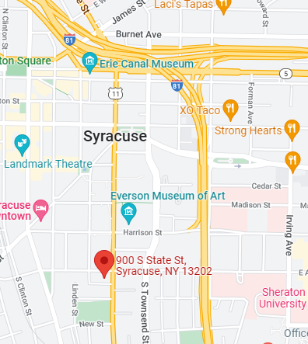
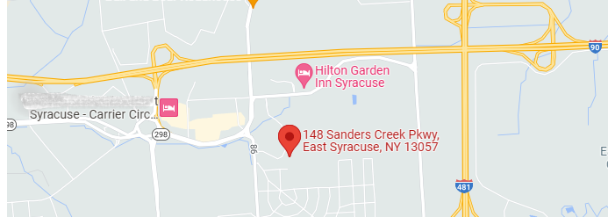
East Syracuse, NY 13057 Syracuse, NY 13202

