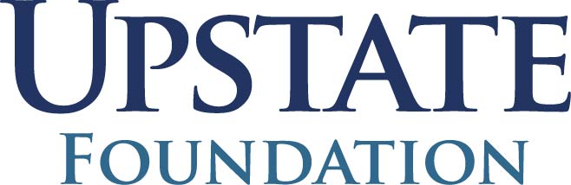

Photo Consent and Release

Covering all Activities (i.e. Camp Triumph, Holiday Party, etc.) carried out by The Burn Foundation of CNY and its affiliates for the 2023 year.
I hereby authorize The Burn Foundation of CNY and its affiliates to take and use still or video photographs of myself, either in conjunction with or without my name for publications, publicity, and/or displays.
I understand these photographs may be used in newspapers, magazines, television or Affiliate Partner publications. ·
I waive any rights I have in such photographs, as well as the privilege of inspecting or approving them or determining their final disposition.

Your Name: _________________________________________
Please Print

Signature: _ Date: _
If you are under 18 years of age, a parent or guardian signature is required.

Parent/Guardian Name: __________________________________________
Please Print

Parent/Guardian Signature: _ Date: _

