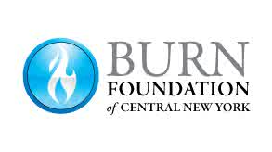

Camp Triumph Counselor Job Description and Requirements

Counselors Report to: Camp Triumph Directors

Position Summary:
A Camp Triumph Counselor is directly responsible for the daily involvement with their cabin residents and/or assigned campers. They will work with other camp counselors to carry out the activities to meet the mission and goals of Camp Triumph. Counselors will supervise campers to ensure the safety, health and administrative regulations during Camp Triumph.
Functions:
- Supervises and participates in all group activities.
- Attends any counselor meetings when requested.
- Interacts with campers and provides a nurturing, supportive environment.
- Responsible for overseeing maintenance and clean-up of cabin and other camp areas throughout the time of camp.
Qualified Counselor need:
- To be over 18 years of age.
- Have a Criminal record release and Background Check.
- Be available for all 4 days of Camp.
- Be sensitive to the diversified needs of children ages 5 to 18.
- Have excellent communication skills, leadership ability and a sense of humor.
A Counselor should be one of these:
- Fire Department employee/volunteer who is familiar with the Burn Survivors.
- Hospital Staff with clinical experience with Burn Children.
- Adult Burn survivor
- The immediate family member/care giver of a Burn Survivor.
- Other allied Healthcare Medical Professional.
- College students enrolled in related Medical field of study.
Working Conditions:
- Outdoor campsites.
- Uneven terrain.
- Changing, unpredictable weather conditions.
Compensation:
Participation is voluntary and unpaid.

Camp Directors have the final decision for acceptance of counselors.

