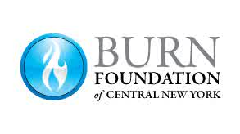

Camp Triumph Counselor Code of Ethics
All counselors must read and agree to abide by the following items.
- All counselors must understand and agree with the mission of Camp Triumph and the Burn Foundation of Central New York and accept the concept that the focus and goals of camp are directed to the campers.
- Counselors are asked not to bring children or family members that do not meet the qualifications to be a camper or counselor at Camp Triumph.
- Counselors will never leave a camper unsupervised.
- Counselors should never be left alone with a camper or campers, even when assisting with personal hygiene or toileting. Someone else, at least, needs to be present in the room.
- Counselors must treat all personal information learned about campers or from campers with respect and confidentiality.
- Counselors will not use profanity or discuss adult subject matter in the presence of campers.
- Counselors will not use or be under the influence of alcohol or illegal substances during camp.
- Counselors are prohibited from having firearms or other weapons while at camp.
- Counselors will comply with the outlined activities and expectations at camp.
- Counselors are prepared and willing to assist campers as needed to meet their daily needs and be sensitive to the developmental differences and abilities of campers.
- Counselors must agree to participate in a background check by providing information requested by the Burn Foundation of Central New York.

Print Name: __________________________________ Date: _________

Signature: _________________________________________

